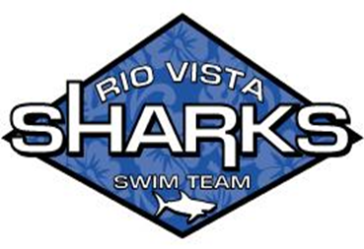Rio Vista Sharks Swim Team—Tips and Tricks for Success! Kids don’t just join our Swim Team…Families do! Remember…We are ALL Parent Volunteers!
What your SWIMMER needs for PRACTICE:
o Practice suit (one piece), fins, towels, goggles (x2), swim cap (x2), and water.
o Sunblock, apply well before practice so it has time to set.
o Be on time!
o Don’t forget a great attitude, good listening skills, and team spirit!
o Parents: during this time be sure to sign up for swim meet jobs at the snack bar. Board members are happy to explain the different job responsibilities to you if you have questions. All parents are required to work jobs at the swim meets, if not you risk your swimmer not being able to swim!
What SWIMMERS and PARENTS need for SWIM MEETS:
o Team suit or suit with team colors, towels, goggles (x2), swim cap (x2).
o Sunblock, apply after each event if possible. You too parents!
o Two or more black Sharpies—they are used for writing event/heat/lane/stroke on arms so each swimmer can be prepared and on time for their race.
o Double the amount of bottled water or beverages you think you need.
o Healthy snacks (i.e.: fruit, crackers).
o Money for the snack bar.
o Dry wicking shirts, cooling towels, a good hat, and shoes (flip flops, crocs).
o Extra towels as they get used often during a swim meet.
o There is Team camping! Bring your EZ-ups and chairs. Don’t have an EZ-up yet? Ask to camp with a family that does! EZ-ups are a great investment think about getting one. There are usually bleachers but the area can get hot and uncomfortable before the end of the meet.
o Swim meet mornings will likely be cold, bring blankets, jackets, parkas to wrap up in between events. o Games, playing cards, electronics, color crayons and paper, or toys to entertain the kids while they wait for their events. If you do bring electronics, consider one of those heavy duty protective cases, as lots of wet kids will be around your device. Of course bring all these things at your own risk!
What PARENTS can expect from SWIM MEET DAYS:
o Your coach needs to know ASAP if you’re not able to make a swim meet.
o All swimmers check in at 7am with their coach! Whether we are at home or away!
o Heat sheets will be posted (at least at home) for parents to take pics of so you can help get your swimmer prepared. (write on arm with sharpie--events/heat/lane/stroke). At away swim meets, if not posted it will be sent over GroupMe. o Swim Meets will usually start around 9am. The sooner the swimmers get checked in the quicker the computer folks can do their part and we can get the meet started!
o Report for volunteer position you signed up for on time!
o Stay aware of events and help get your swimmer to the ready bench—this helps swim meet run faster if we are not waiting on swimmers.
o Keep your area cleaned up and put your litter in the trash.
o Parents are expected to help with pool setup and break down for Swim Meets. Please try and do one or the other for every meet.
o You will be there for hours!
o It will more than likely be hot!
o Each race will be exciting! Get out there and cheer for all the swimmers!
o You will burst with pride the first time your kid makes it across the pool and gets a heat ribbon! Ok…everytime!

